Final Report

PET PICK THROUGH

Team

Project Group 12

Jagadish Tirumalasetty

Surya Botcha

Sri Kailash

Kishore

Index

1. Introduction
   1. Motivation
   2. Significance
   3. Objective
2. Project Description
3. User Manual
4. First increment
5. Second increment
6. Third increment
7. Presentation Material
8. Project Management
9. Challenges Faced

Introduction

**Motivation:**

The motivation of our project Pet Pick Through (Search) was to bring value to people through technology. We started with designing multiple applications targeting different audiences and different needs for which people might really need something or someone to help. Combine this motivation of ours with large public data available for open use, we tried to bring value to this data which otherwise would be a great task in itself to collect such large amounts of data of such importance. We singled on KCMO public data released by The Department of Animal Control.

We wanted our application to reach the maximum number of audience and our application design turned out to be an application which people would find most useful in times of emergency. So, we found it apt to develop a mobile application. We chose the Android platform to develop the mobile app.

In a way the data we are using is provided by public. Their random acts to help an animal or unattended pets by reporting them to the authorities actually is logged and kept track of. This generates a huge amount of invaluable data. Where else would we get such detailed information of all the incidents regarding animals from multiple locations within a city?

**Significance**:

The significance of our project is making the vast amount of public data available to people in a way that it would really turn out to solve a purpose rather than just left to be used for some random reports. We are using the The Department of Animal Control data which logs each and every request or complaint that it recevies to help so family/person to possibly track their lost pet. We all know and see multiple incidents of helplessness of a family when they loose their pets. Irrespective of how early they report the disappearance of their pets.

**Objective:**

The main objective is to give a person some pointers to locations from where he/she can start searching for his or her pet.

We always see multiple notes/posters by people giving out details of their lost pets and share contact details in case anyone happens to find any clues or where abouts. This is a very common situation. When you lose your pet you start searching places around your house or at the maximum you could walk up to your neighbors and query about any clues. After that you possibly wouldn’t know people from any more than two or three houses from your house. So, it basically limits your reach for search. This is when you resort to posting fliers. We with our app are reversing the situation. You get help from people you wouldn’t know when they report an incident to the authorities. It is understandable that people in general would want to help out animals in person but most of them wouldn’t know the family of pet in person so they would rather report it to the authorities. Our app lists out all such entries and incidents. In case you lose your pet all you would have to do is open the app and read through incidents close to where you think lost your pet. When you find multiple entries around that location and adjacent to it close to the time when your pet disappeared from you, you can assured that it definitely is your pet.

All you have to do is drive up to that location and start looking ask where about as would do around your house. Our app tracks your location using GPS on your mobile and would help you to navigate to the target location. In case the authorities have already taken custody of you dog the app has the request numbers of each incident and you could use this request number with The Department of Animal Control to track down your pet about where it has be taken to.

Project Description

**System Features:**

* Android Development Tool(4.4 version)
* Eclipse ADT
* IBM Bluemix Mobile Cloud Storage

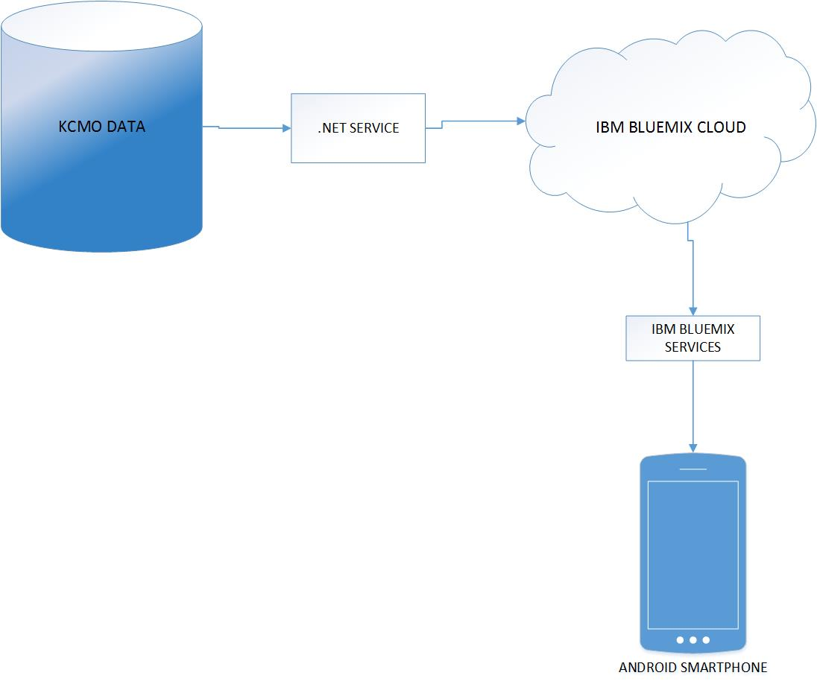

System Architecture

User Manual

The app shows the opening screen with the buttons play game, pie chart, line chart as shown below.

* The main applications page of an android looks as it is shown and our application pet pick can be seen as shown:

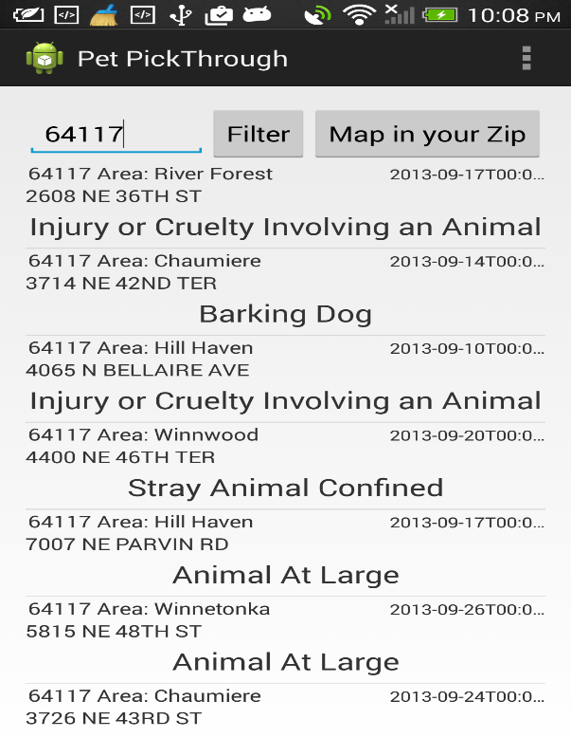

The above screen lists all the incidents. The search fields enable users to search using the zip code where the user thinks the pet disappeared.

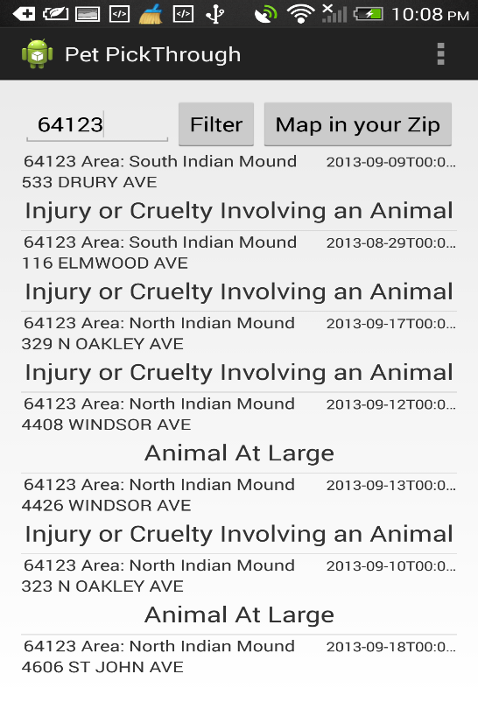

To use the application:

1. User needs to open the application
2. Once the list of all incidents are listed. The user can scroll through the incidents and can click on an item if he feels that might be related to an incident
3. User can also use filter button to filter the list based on zip code. This way the list is filtered to all incidents related to the zip code. This way user gets to see multiple reports of possible same incident. This can be guessed by naked eye. Multiple reports centered on a location can be identified.
4. Upon loading of the maps page the GPS tracker shows user location and the destination location.
5. User can use the GPS tracker to navigate to the destination Location.

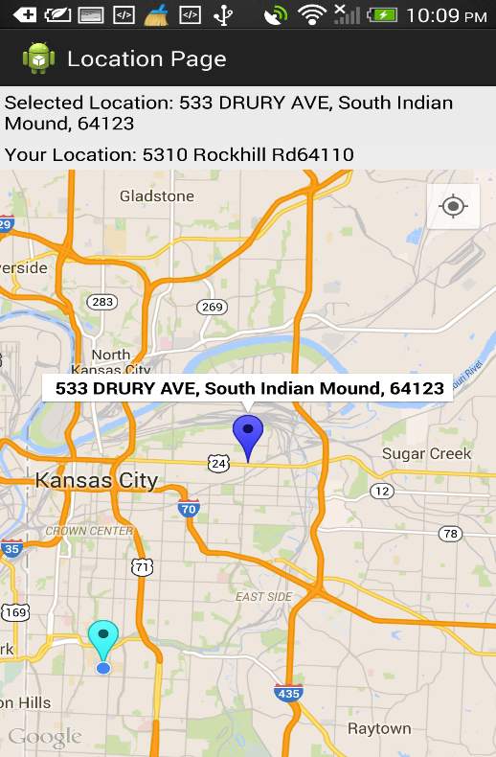

The marker in light blue is the user location. The blue dot is the GPS tracker using which user can navigate to the target location.

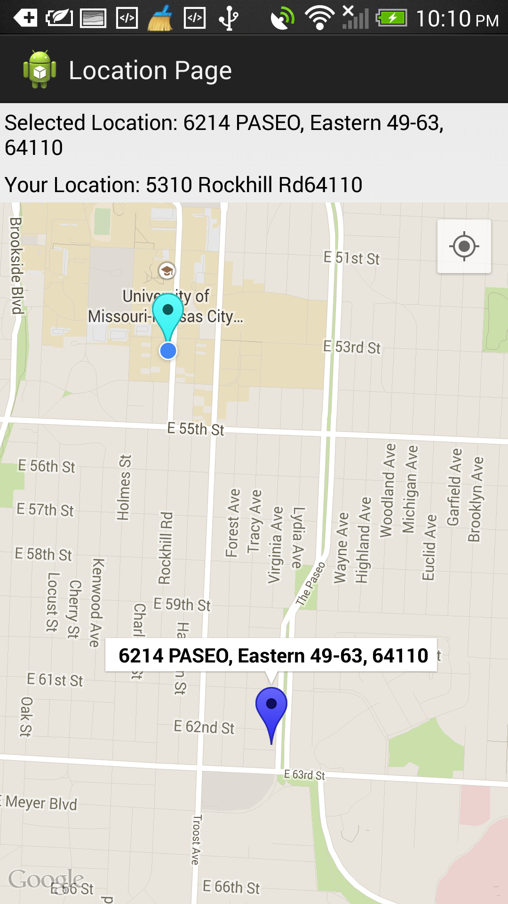

This image shows how effectively the app could work. The location is close by to the user location but without the application the user would possibly not be able to single on the location.

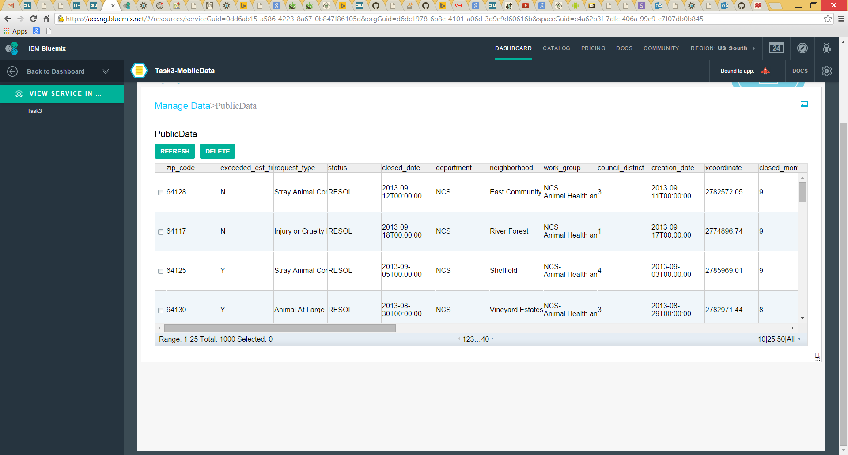

This shows the DataSet hosted on IBMCloud

First increment

* **AIM:**
* Our project mainly focuses on relating technology with the real world. Our application is motivated from the thought that all the people who are in need of help and the people who want to take an initiative to help voluntarily must be provided a platform. In this process, we were succeeded by creating the overall technical view of the project and also started working on it. The work which we had done is included in this First Increment Report.
* **SERVICES AND API’S USED:**
* The first task that we had done in our application was creating a new Database. By using MySQL Server, we created a new database which is useful for our application. All the data that is given by the user in the client side can be stored in this database and can be retrieved as per user functions.
* We created a web service using .net coding in Microsoft visual studio for the login page in order to store the data in our database and to retrieve it and for comparing the details with the database for verification.
* The link for our web service is

kc-sce-cs551-2.kc.umkc.edu/aspnet_client/Group12/WCFService1/Service.svc

* In the login page, we created an option to login directly by using the Google + sign in. For this we used Google API.
* **DESIGN DETAILS:**
* The details are included in the scrum do in terms of stories and they can be accessed at

<https://www.scrumdo.com/projects/project/help-help-help/iteration/111976>

* **SEQUENCE DIAGRAM:**

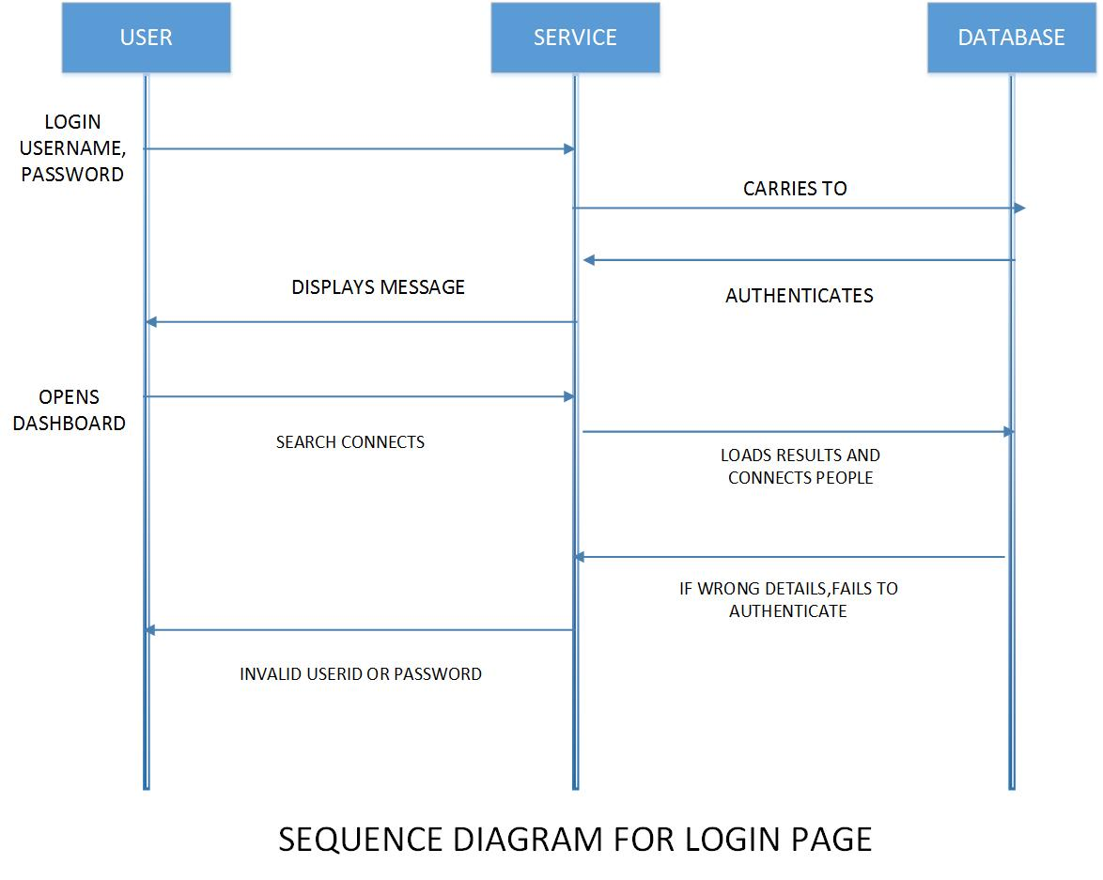

* **USER INTERFACE:**
* The main applications page of an adroid looks as it is shown and our application Ivolunteer can be seen as shown:

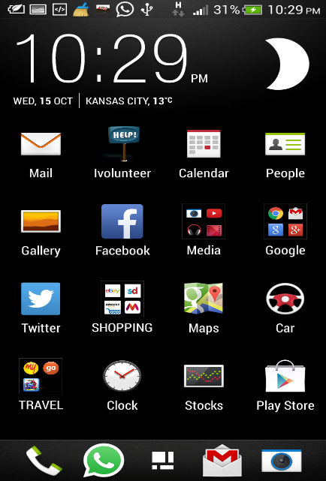

* The login screen for the applications is as follows:

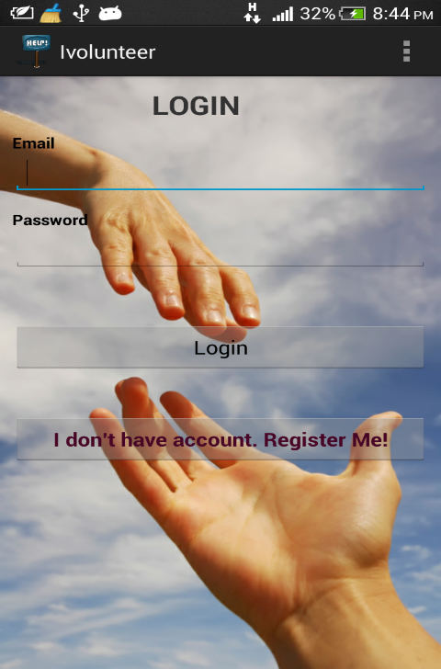

* A toast option is used to review the functionality of the buttons inserted:

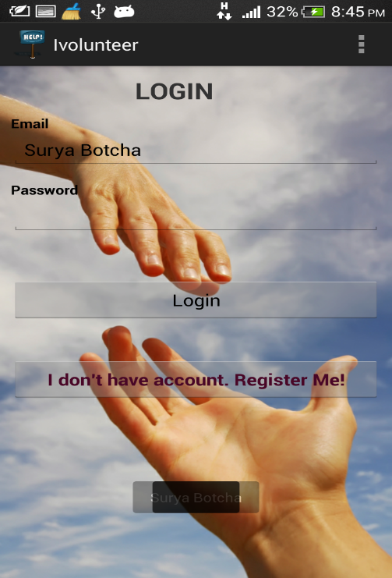

* The user gets directed to a new page which is the register page if he is not a registered member:

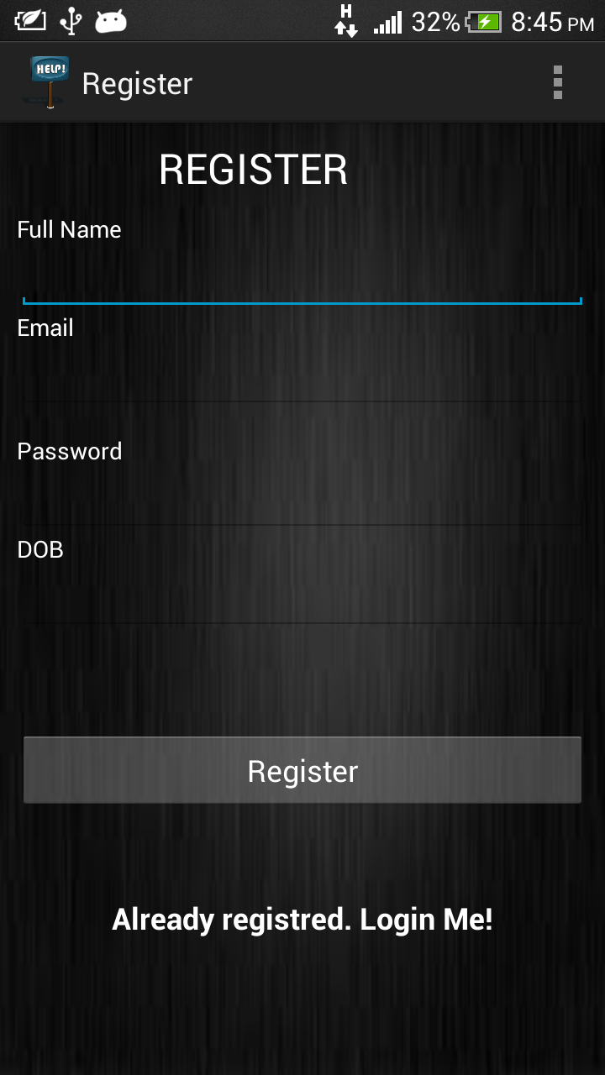

Second increment

* **AIM:**
* Our project mainly focuses on relating technology with the real world. Our application is motivated from the thought that all the people who are in need of help and the people who want to take an initiative to help voluntarily must be provided a platform. In this process, we were succeeded by creating the overall technical view of the project and also started working on it. The work which we had done is included in this First Increment Report.
* **SERVICES AND API’S USED:**
* The first task that we had done in our application was creating a new Database. By using MySQL Server, we created a new database which is useful for our application. All the data that is given by the user in the client side can be stored in this database and can be retrieved as per user functions.
* The Google API is used and the maps and places are integrated in the project. The key for places and maps is generated and it is embedded in the android studio project.
* We created a web service using .net coding in Microsoft visual studio for the login page in order to store the data in our database and to retrieve it and for comparing the details with the database for verification.
* The web services for retrieving and string the data is written and is loaded into GitHub.
* **DESIGN DETAILS:**
* The details are included in the scrum do in terms of stories and they can be accessed at

<https://www.scrumdo.com/projects/project/help-help-help/iteration/111976>

* **SEQUENCE DIAGRAM:**

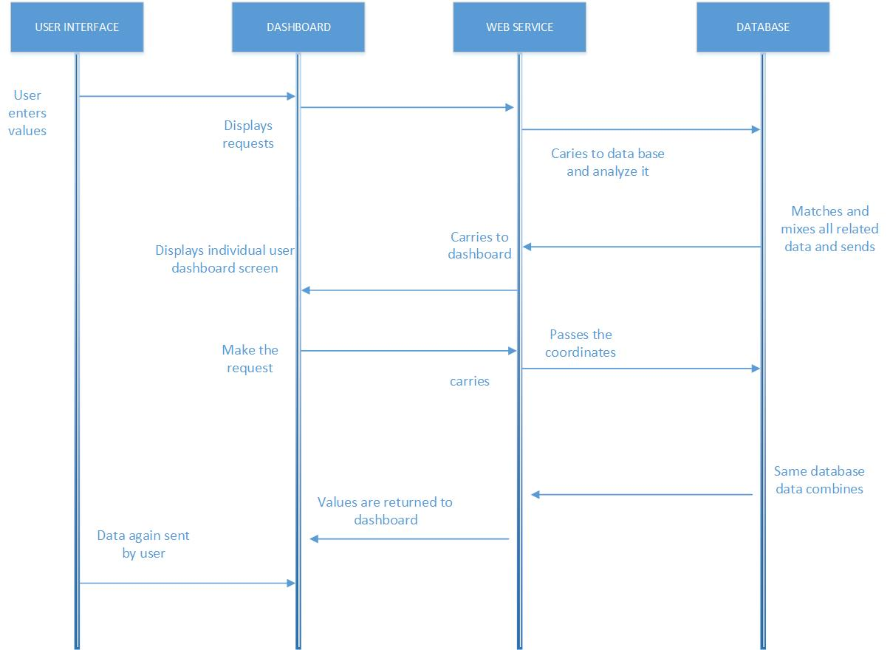

**SEQUENCE DIAGRAM FOR DASHBOARD**

* **USER INTERFACE:**
* The main applications page of an adroid looks as it is shown and our application Ivolunteer can be seen as shown:



* The login screen for the applications is as follows:



* The user gets directed to a new page which is the register page if he is not a registered member:



* **MAPS AND PLACES API:**
* The google maps and places ae used to search the nearest locations. This is implemented by using google API and the user interface is designed using XML script.
* The screenshots of the Application are as shown below.

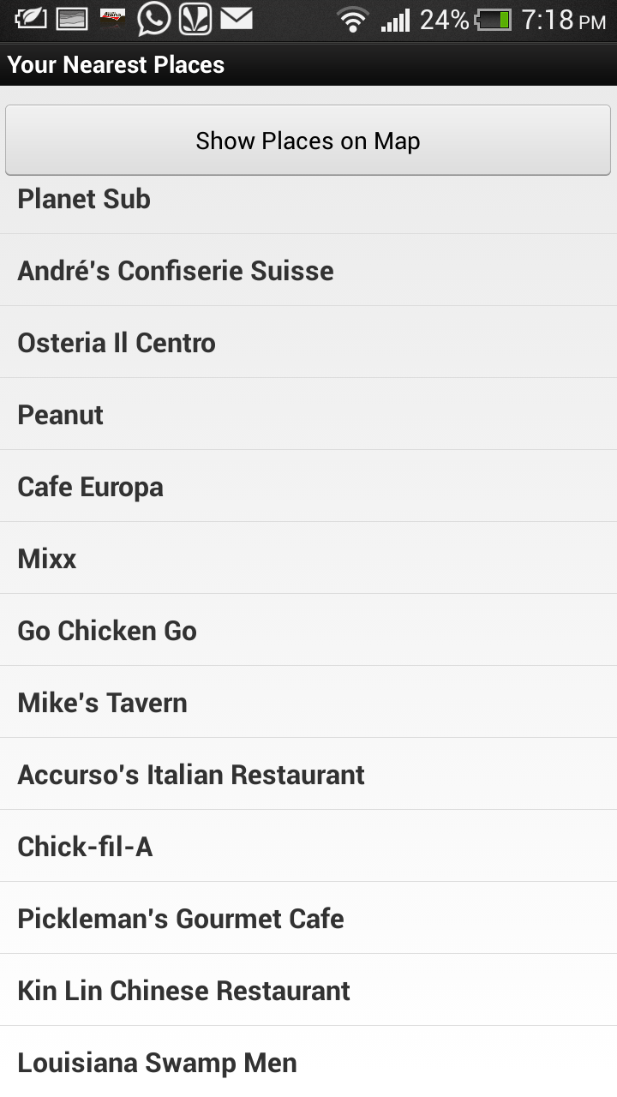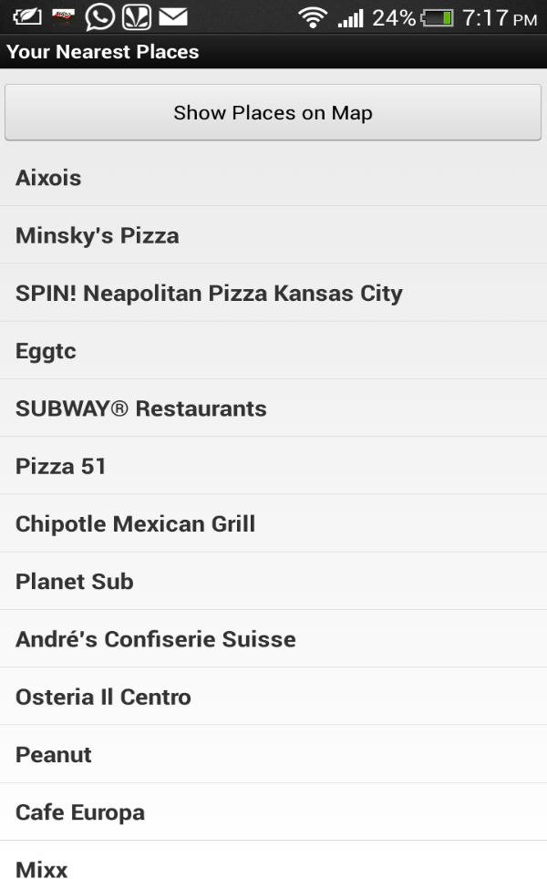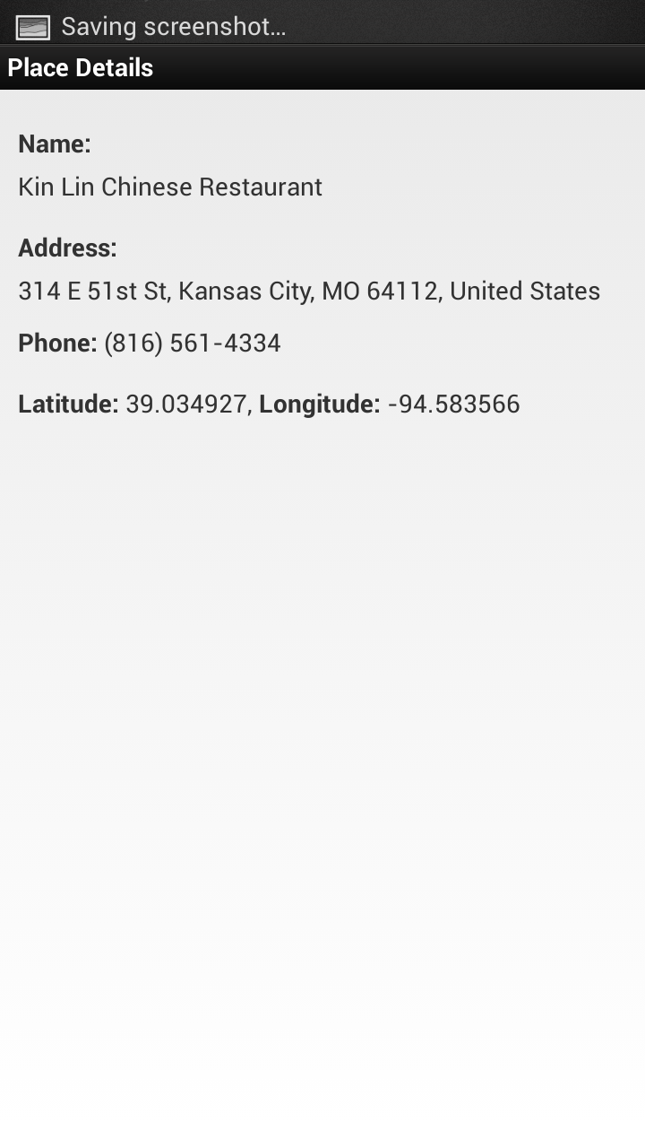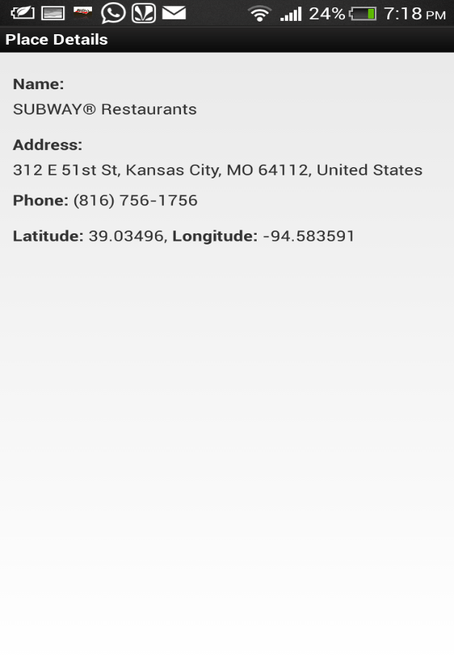

* **TESTING:** Web services were implemented using visual studio and the corresponding testing tools were used and the results were obtained.

The results obtained from testing were taken as screen shots and are attached below.

1. Below screenshot is the code belonging the login user and it is tested and the results can be seen at the bottom dialog box of the screenshot.

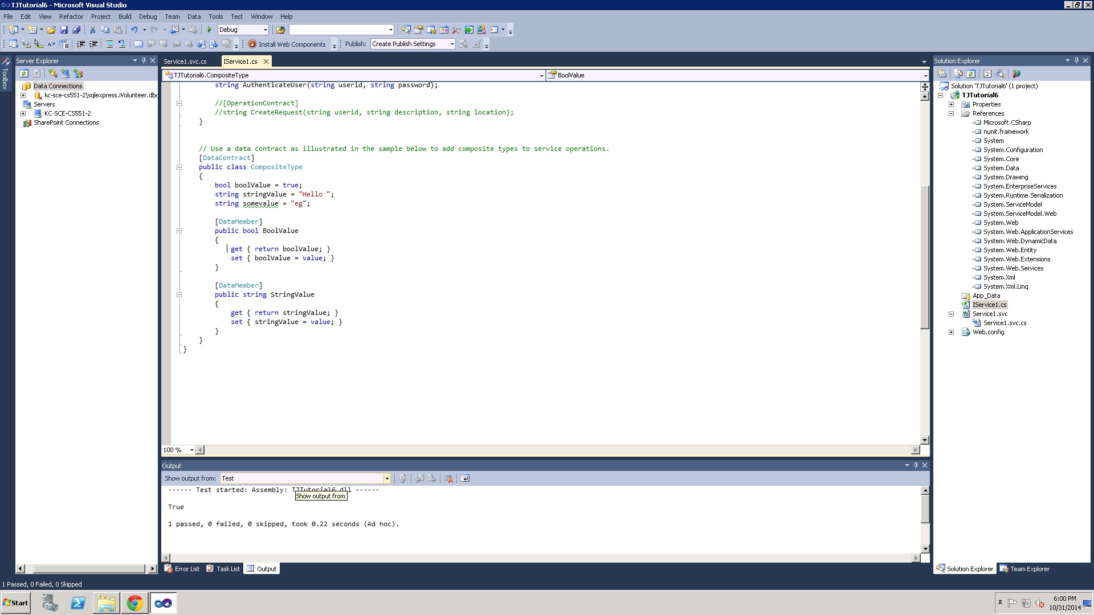

2.

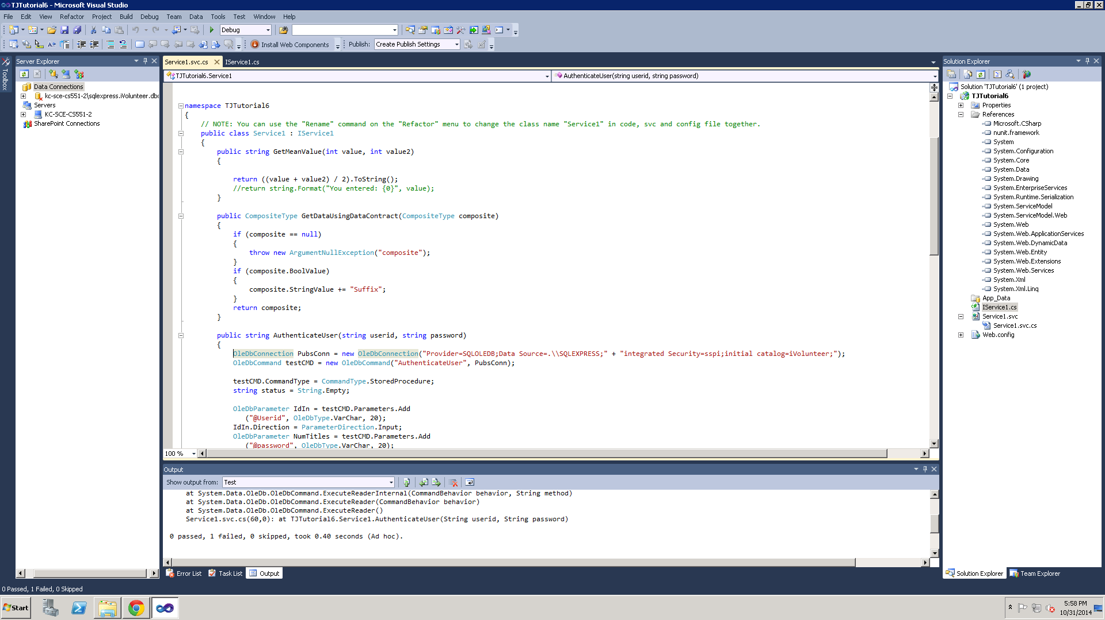

3.

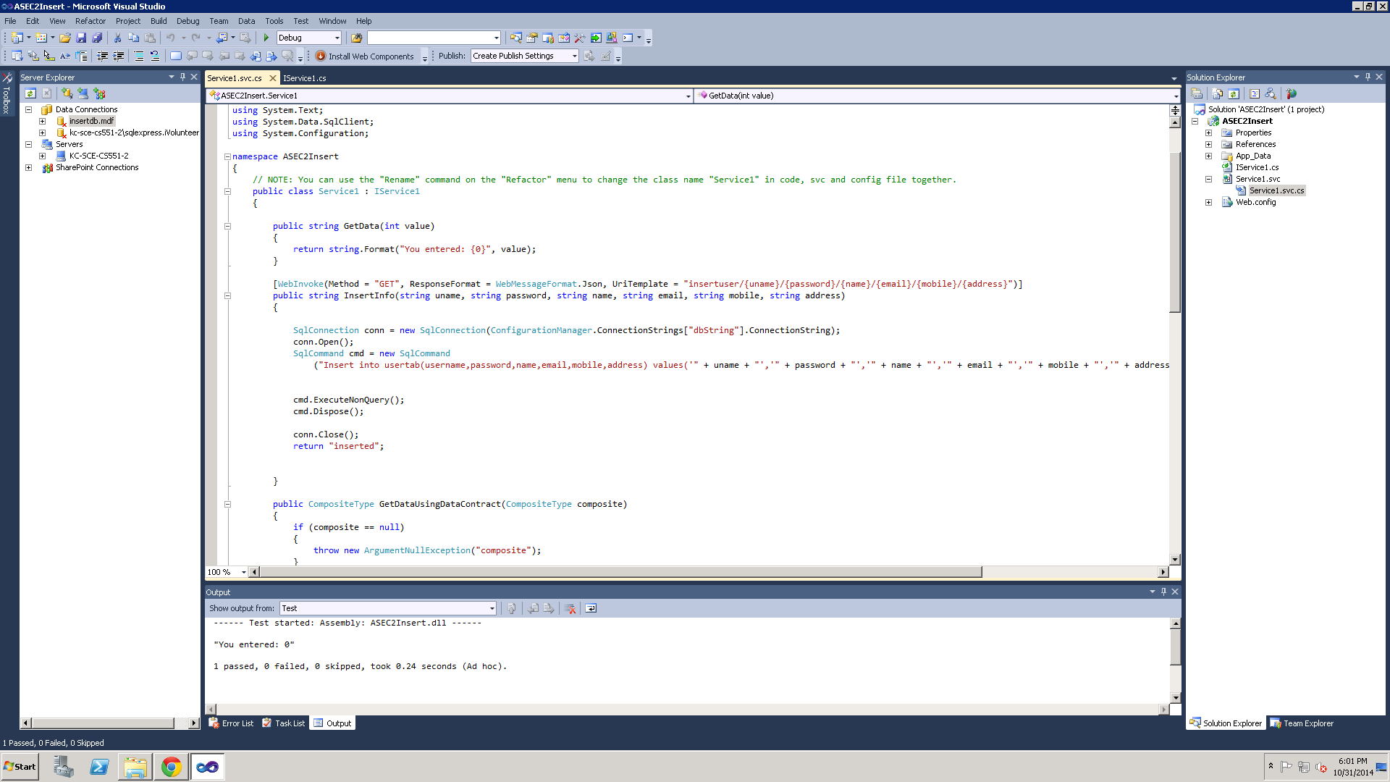

4.

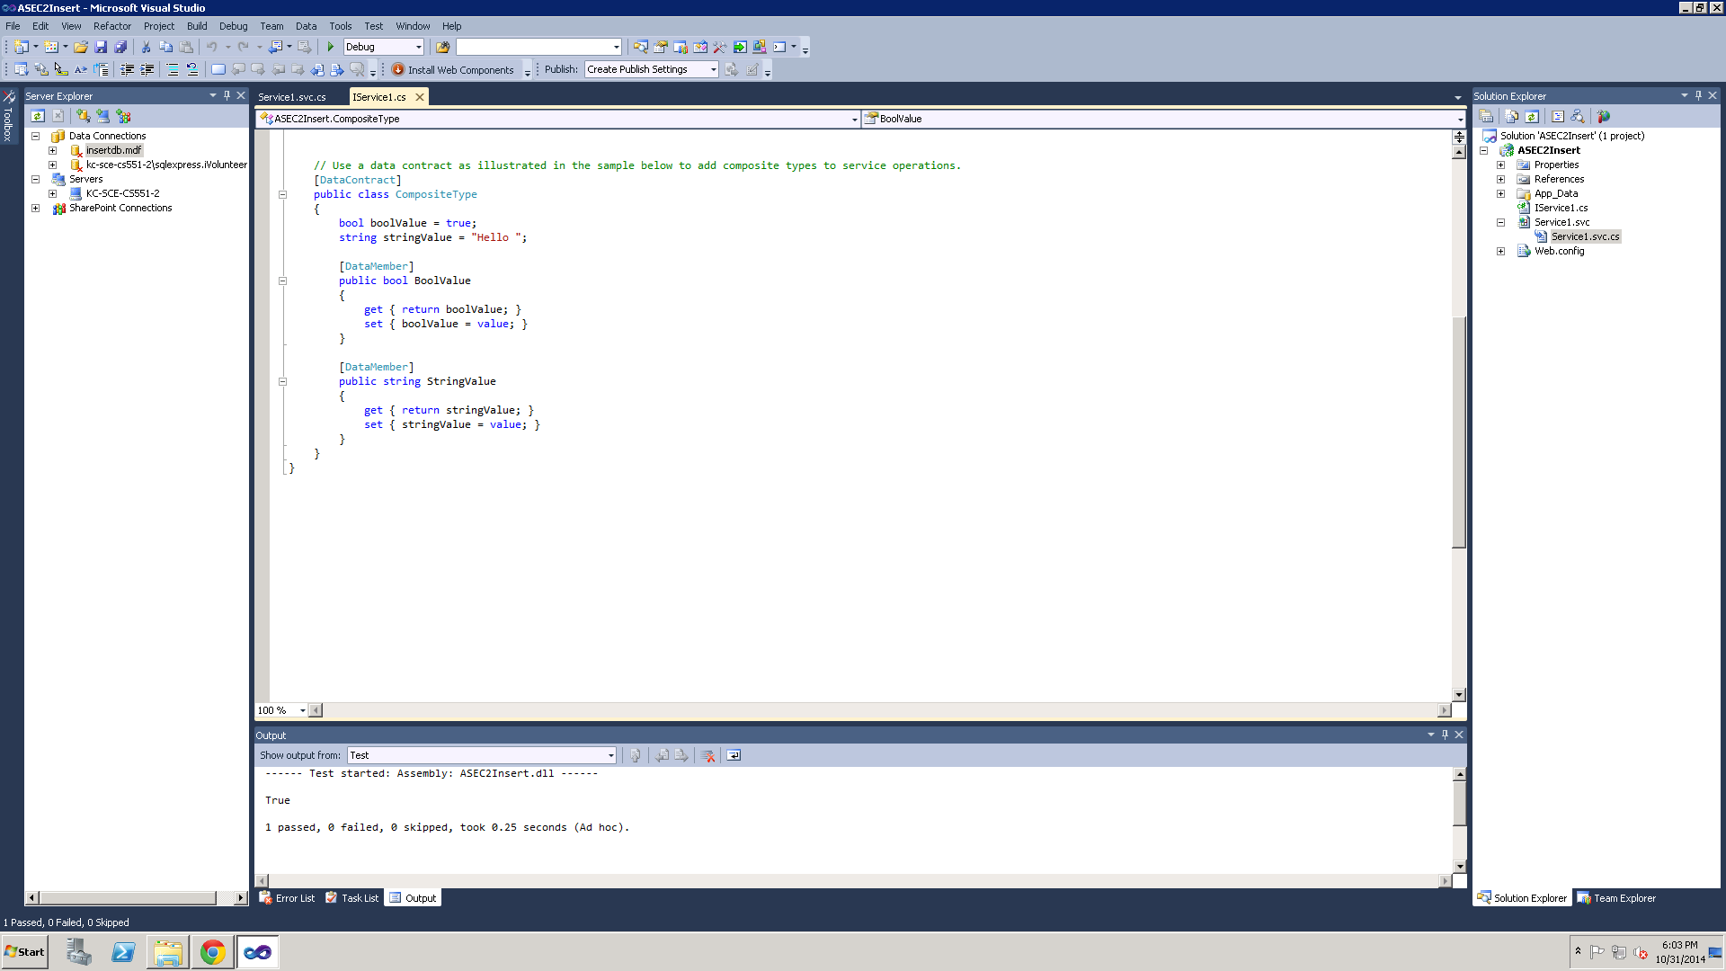

* GITHUB LINK:

https://github.com/sbbb2/IVolunteer/tree/master/Increment%202

Third increment

* **AIM:**
* Our project mainly focuses on relating technology with the real world. Our application is motivated from the thought that there are many people who love pets and also take care of them. We can observe most of the houses which raise a pet. By considering the recent statistics of pet loses, we came up with an idea how important it is to initiate an application which helps for lost pet search. Whenever we lose our pet, we don’t remain silent instead we try calling 911 and lodging a complaint about our lost pet. Also we can observe cases where people voluntarily call to give details about found pets and also about the location in which the pet was found with identification about the pet. So if we provide these people with an application letting them know about the basic idea where their pet was seen, they could start searching from that location.
* **SERVICES AND API’S USED:**
* The first task that we had done in our application was creating a new Database. By using IBM Bluemix Cloud, we created a new database which is useful for our application.
* The Google API is used and the maps and places are integrated in the project. The key for places and maps is generated and it is embedded in the android studio project.
* IBM Bluemix service is used to retrieve the data from database to the user where it acts as inbuilt web services instead of considering web services separately.
* The details are included in the scrum do in terms of stories and they can be accessed at

<https://www.scrumdo.com/projects/project/help-help-help/iteration/111976>

* **SEQUENCE DIAGRAM:**

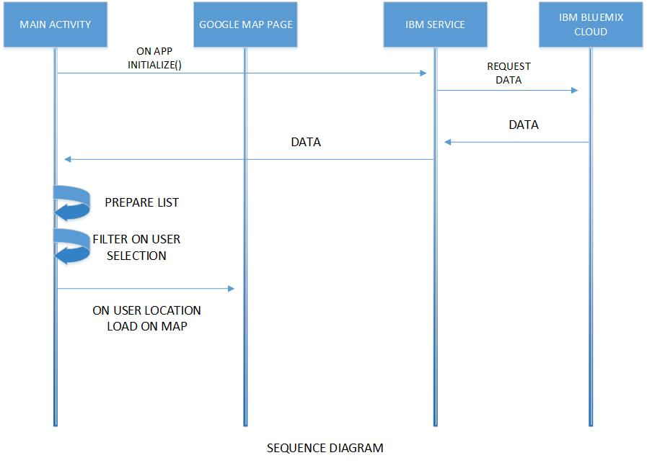

**SEQUENCE DIAGRAM FOR DASHBOARD**

* **USER INTERFACE:**
* The main applications page of an adroid looks as it is shown and our application pet pick can be seen as shown:



* Once the zip code is selected, all the complaints lodged in that region are displayed.



* When we select a particular complaint that is lodged, we can see the address from where the particular request is received and also the location is shown using the Google Maps API. The GPS tracker is used to get the current location.



* In the similar way let us see by considering another zip code where some request is obtained stating about the lost pet

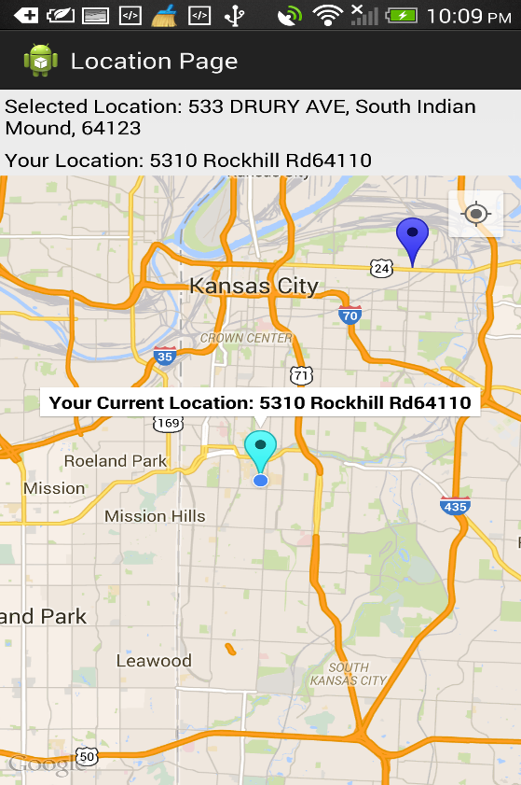

* The below screen shot displays the complaints which are lodged in the area where the zip code is 64110.



* **MAPS AND PLACES API:**
* The google maps and places ae used to search the nearest locations. This is implemented by using google API and the user interface is designed using XML script.
* The screenshots of the Application are as shown above.
* The google maps API was used to track the exact location from where the pet request was obtained.
* **TESTING:** Web services were implemented using visual studio and the corresponding testing tools were used and the results were obtained.

The results obtained from testing were taken as screen shots and are attached below.

1. Below screenshot is the code belonging the login user and it is tested and the results can be seen at the bottom dialog box of the screenshot.



2.



3.



4.



* GITHUB LINK:

https://github.com/sbbb2/IBM-HACKATHON/tree/master/FinalProject/HackathonSample

* YOUTUBE VIDEO LINK:
* <https://www.youtube.com/watch?v=BDF0P0XWHxs&feature=youtu.be>

Presentation Material:

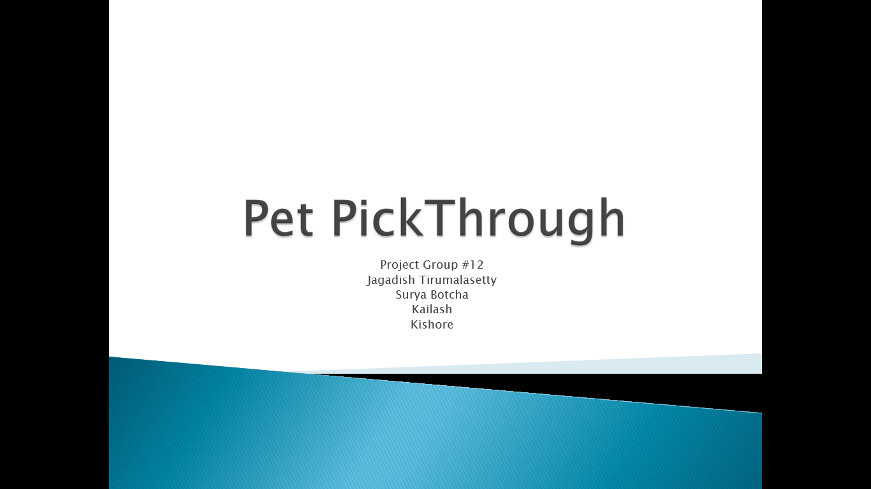

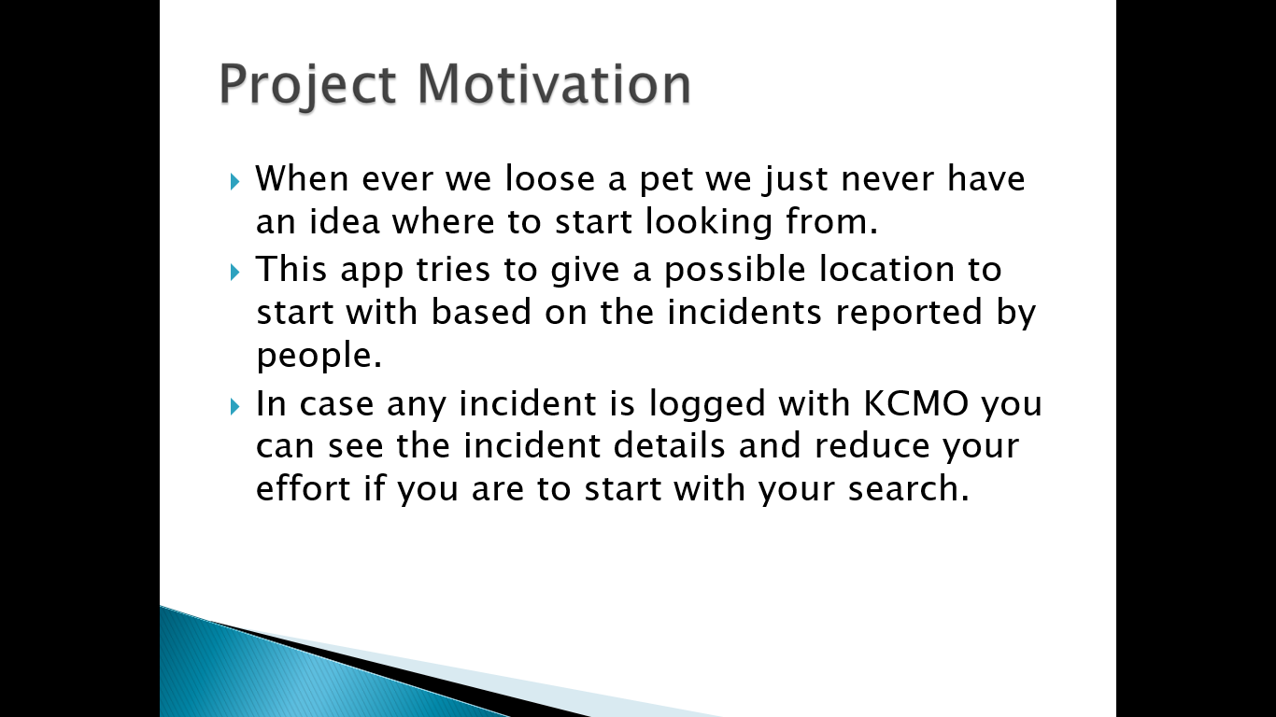

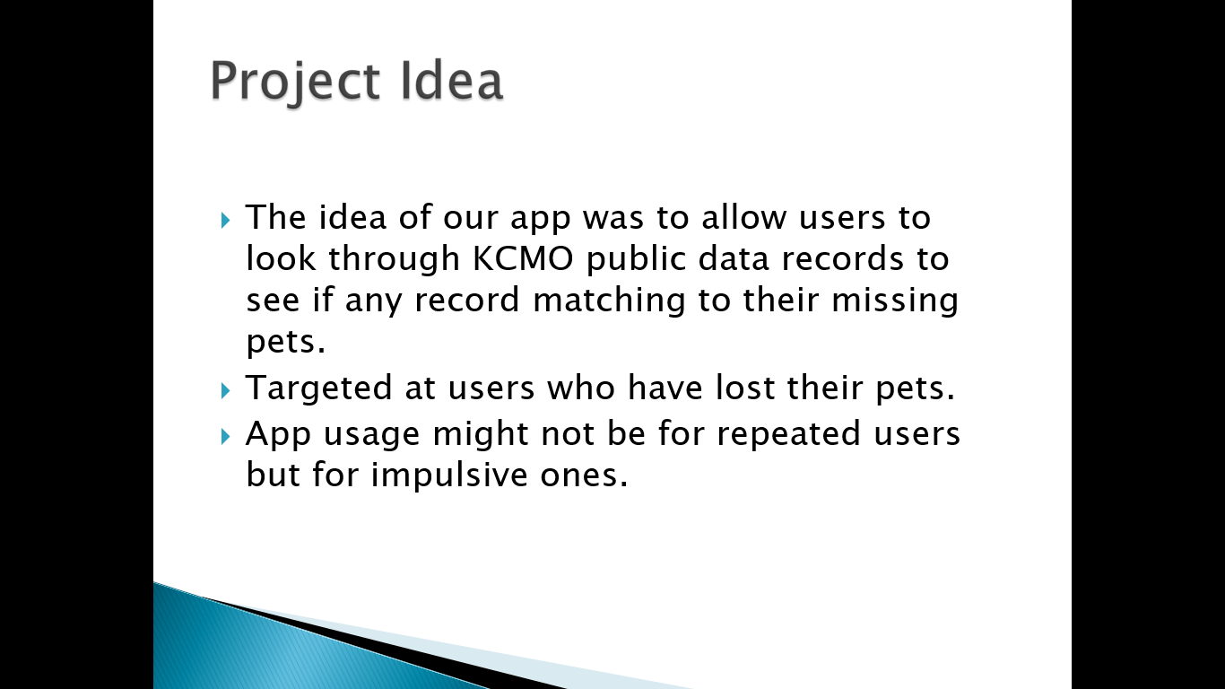

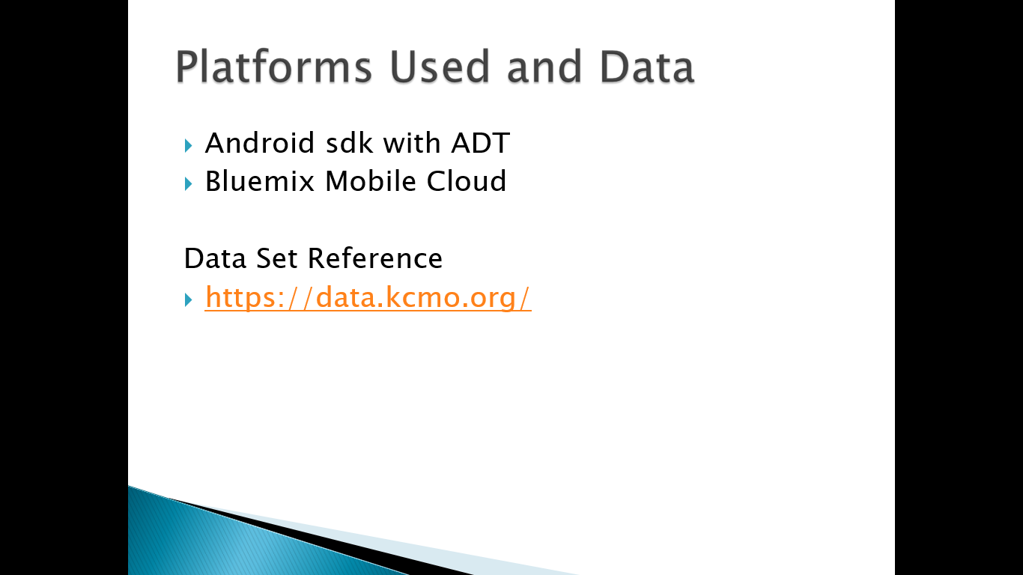

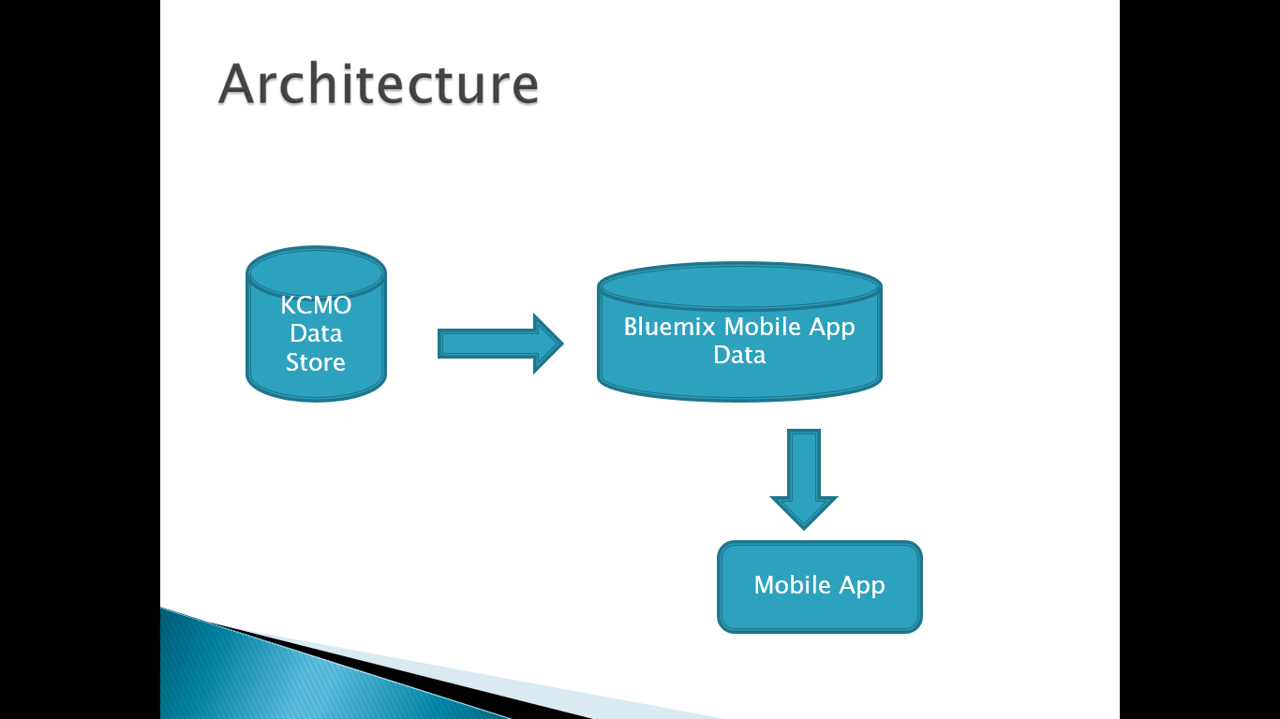

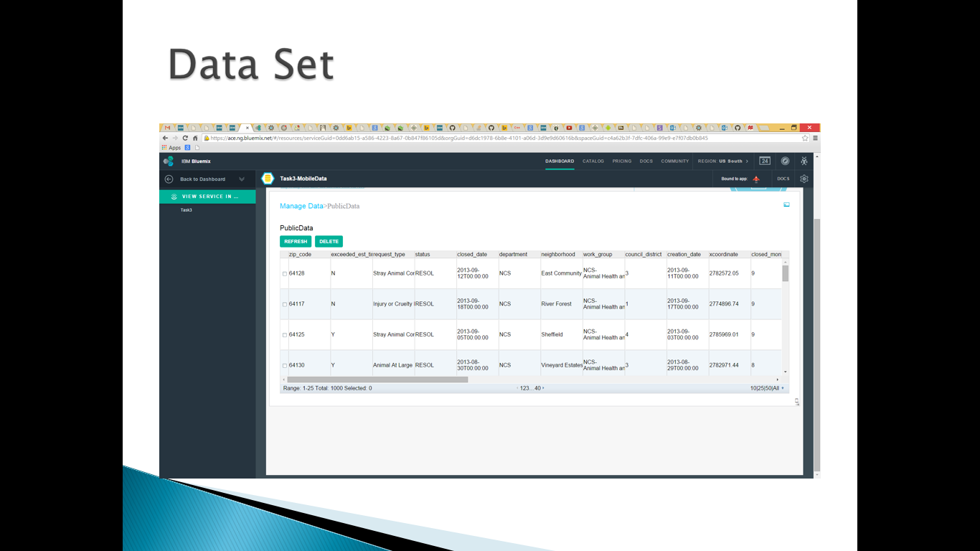

Project Management:

* We used ScrumDo to manage our project development.
* Below is the ScrumDo url:

<https://www.scrumdo.com/projects/project/petpickthrough/summary>

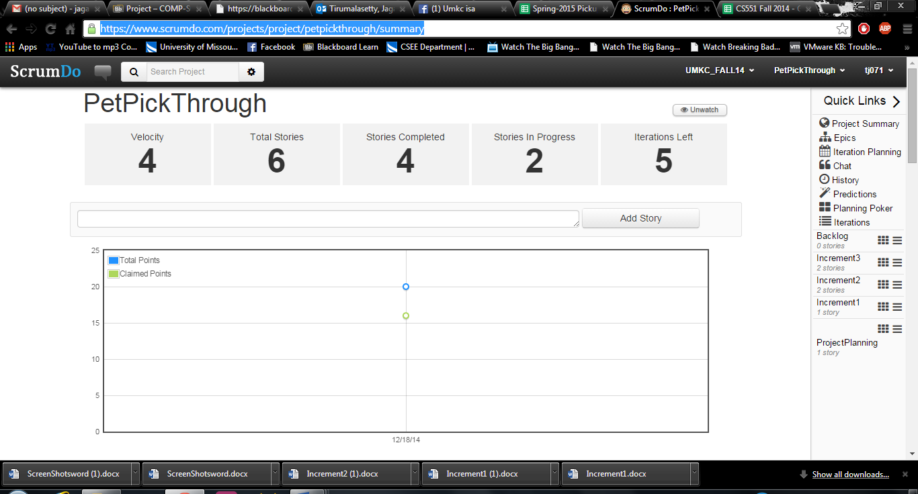

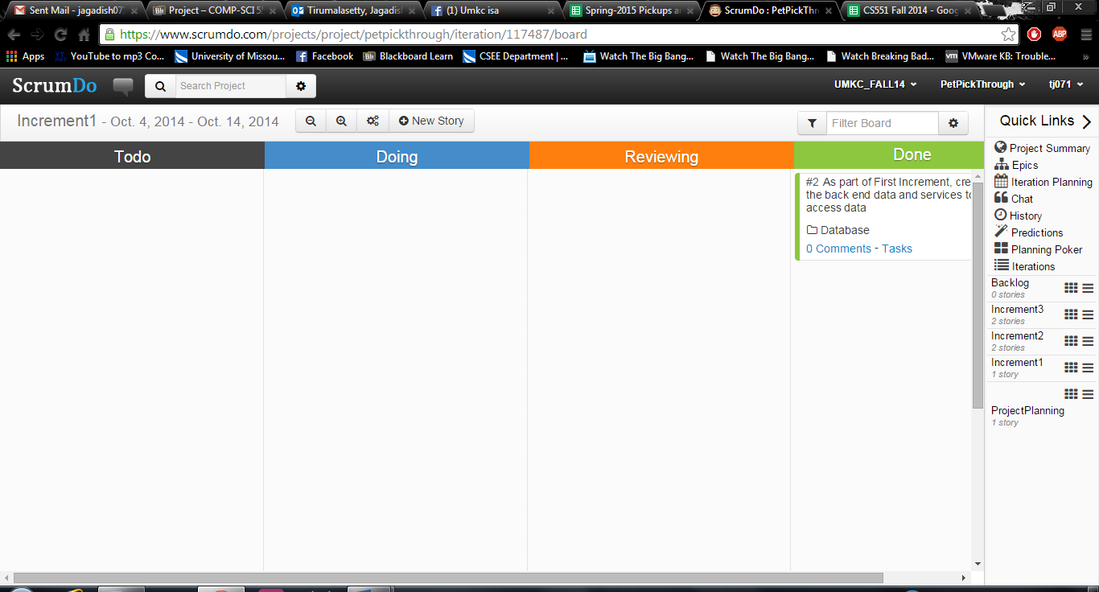

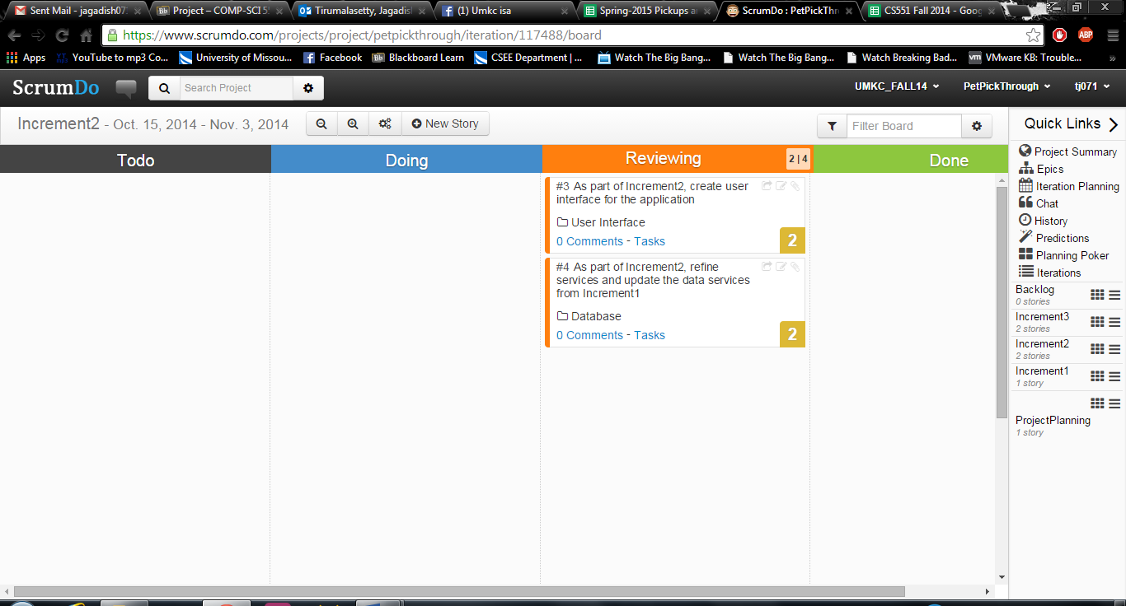

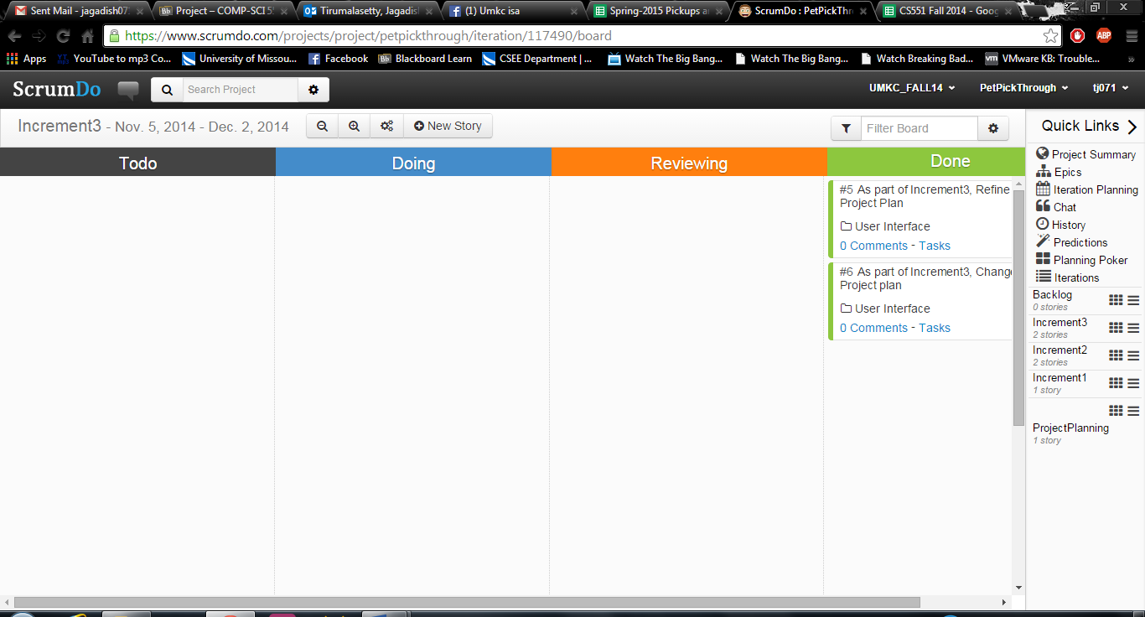

Final Project Evaluation:

The final project was great learning experience. The involvement in similar courses in the past two semesters gave as an idea on how to approach with the project planning and development. We started with an optimistic plan of developing a iVolunteer application. This was supposed to be an Android app too. But, with the time progressing we reached a stage where we had iVolunteer with all the database and services up and a IBM Hackathon winning project idea of PetPickThrough. Given we had to put in same effort to build any of these two applications we chose to continue the PetPickThrough which had much more scope to turn out to be an practical and useful application. The whole project development was associated in line with the challenges as part of the course work. Whatever we learned in course we tested it in the challenges and took out the learning from these challenges into the project.

The challenges and Project were like helping each other. There were definitely deviation from our actual project and what we developed in challenges but the effort was minimized to maximum extent as we were using similar components. For our team personally the challenge project turned out to be actual project. So, as far as our team we were very happy with how the course work was planned.

Looking back at things and when we think what we could have done better, I would say we must have researched much more when deciding about the project. We initially stuck to the idea of developing an Android application and searched for ideas to fit in. Rather it should have been the idea first and then decide the platform. We were skeptical off the expectations and forced ourselves onto android prior to having a solid plan. But thanks to you for being flexible and giving us an option to pursue the idea rather than restricting us to working on what we didn’t find interest in after a point.

Over all it was a very learning experience, and we feel like we are taking away so much of learning and experiences from the course work and project and all the challenges.

Challenges Faced

1. Integrating IBM cloud data with Android.
2. Page Navigation on Android with retaining the user selection Information
3. Initial list loading from IBM Cloud takes multiple seconds to load. We could not improve the performance on data load on the home page